**Task No. 1:** Import File using Pandas.

**Solution:** import pandas as pd

df=pd.read_csv('Customer Call List.csv')

df

**Output:**

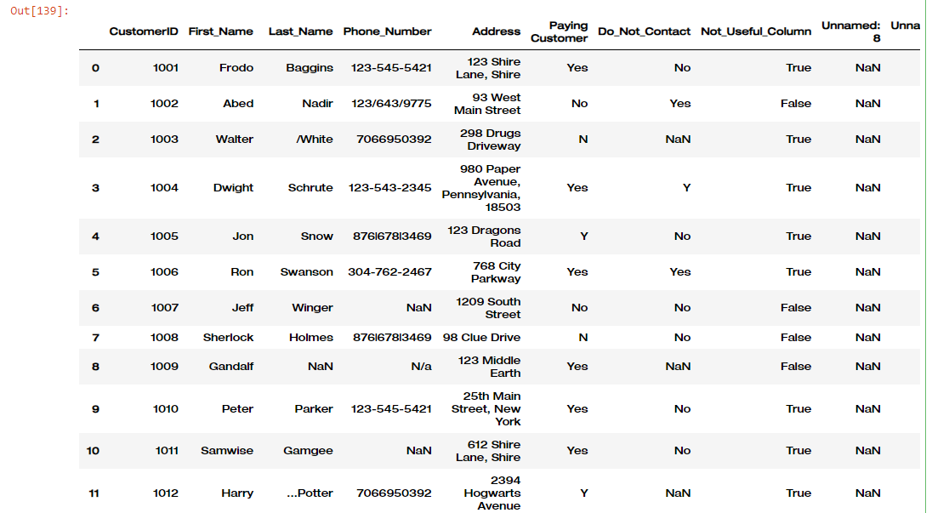

**Task No. 2:** Drop Duplicates

**Solution:** df.drop_duplicates()

df

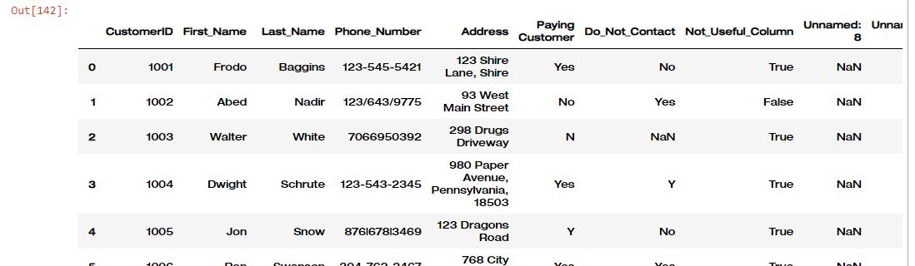**Output:**

**Task No. 3:** Remove ‘..’ & ‘/’ in Last-Name Column.

**Solution:** df['Last_Name']=df['Last_Name'].str.strip('/')

df['Last_Name']=df['Last_Name'].str.strip('..')

**Output:**

**Task No. 4:** Replace ‘|’ & ‘/’,’N-a’ with ‘-’ in Phone_Number Column and fill the null value with 0.

**Solution:** df['Phone_Number']=df['Phone_Number'].str.replace('|', '-').str.replace('/', '-').str.replace('N-a', '0')

df['Phone_Number']=df['Phone_Number'].fillna(0)

**Output:**

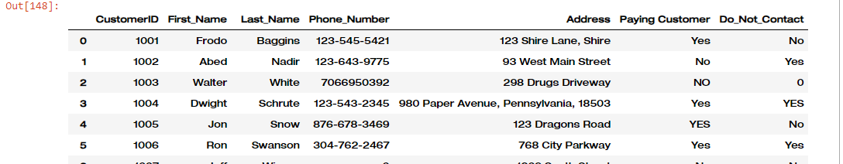

**Task No. 5:** Drop Unused Columns.

**Solution:** df=df.drop(['Unnamed: 8','Unnamed: 9','Not_Useful_Column'],axis=1)

**Output:**

**Task No. 6:** Replace y/n value with yess/no in Paying Customer, Do_Not_Contact and fill null values with 0.

**Solution:** df['Paying Customer']=df['Paying Customer'].replace({"N":"NO","Y":"YES",'N/a':'0'})

df['Do_Not_Contact']=df['Do_Not_Contact'].replace({"N":"NO","Y":"YES"})

df['Do_Not_Contact']=df['Do_Not_Contact'].fillna(0)

df['Address']=df['Address'].fillna(0)

**Output:**

**Task No. 7:** Insert ‘-’ to every 3 digits in Phone Number Column

**Solution:** def format_phone_number(phone):

if pd.isna(phone):

return phone

phone = str(phone)

if '-' not in phone:

return f"{phone[:3]}-{phone[3:6]}-{phone[6:]}" if len(phone) >= 6 else phone

else:

return phone

df['Phone_Number'].apply(format_phone_number)

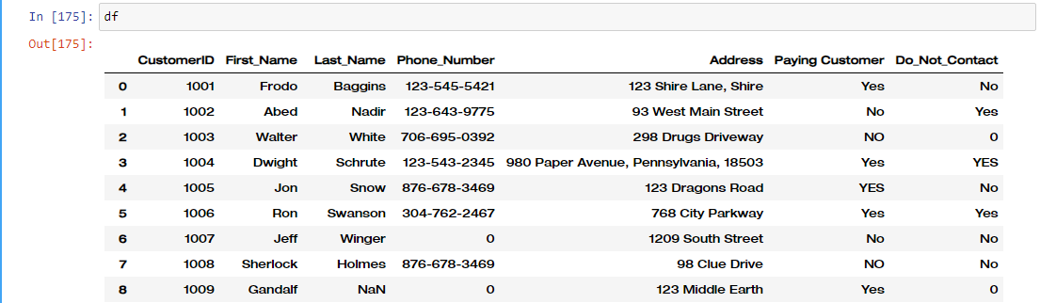**Output:**